Aim

Set 20: Stock Analysis
Data Visualization using R

To analyse stock prices using a line chart, a bar chart, a table and a dashboard in R.

Procedure
- Open RStudio and load the packages ggplot2 and gridExtra (install them once with install.packages(c("ggplot2", "gridExtra"))).
- Create the stock data as a data frame.
- Question 1: draw the line chart of the three stocks with geom_line().
- Question 2: calculate the daily % change of Stock A with diff() and draw the bar chart.
- Question 3: make the table with tableGrob().
- Question 4: join the charts and the table into a dashboard with arrangeGrob().
- Run the code and note the output and the figures.

R Code
library(ggplot2); library(gridExtra)

# Dataset
stocks <- data.frame(Date = as.Date(c("2023-01-01","2023-01-02","2023-01-03")), Stock_A = c(100, 105, 110), Stock_B = c(150, 152, 148),
Stock_C = c(120, 118, 122))
print(stocks)
change <- data.frame(Date = stocks$Date[-1],
Change = diff(stocks$Stock_A) / head(stocks$Stock_A, -1) * 100)
print(change)

# 1. Line chart - three stocks
p1 <- ggplot(stocks, aes(Date)) +
geom_line(aes(y = Stock_A, colour = "Stock A")) + geom_line(aes(y = Stock_B, colour = "Stock B")) + geom_line(aes(y = Stock_C, colour = "Stock C")) +
labs(title = "Stock Prices", x = "Date", y = "Price", colour = "Stock")

# 2. Bar chart - daily % change of Stock A
p2 <- ggplot(change, aes(factor(Date), Change)) + geom_col(fill = "seagreen")
+ geom_text(aes(label = paste0(round(Change, 2), "%")), vjust = -0.5) + labs(title = "Daily % Change of Stock A", x = "Date", y = "Change (%)")

# 3. Table
tb <- tableGrob(stocks, rows = NULL)

# 4. Dashboard
dash <- arrangeGrob(p1, p2, tb, layout_matrix = rbind(c(1,2), c(3,3)), top = "Stock Dashboard")

ggsave("set20_q1.png", p1, width = 6, height = 4, bg = "white") ggsave("set20_q2.png", p2, width = 6, height = 4, bg = "white")
ggsave("set20_q3.png", arrangeGrob(tb, top = "Stock Price Table"), width = 5, height = 2, bg = "white") ggsave("set20_q4.png", dash, width = 12, height = 8, bg = "white")

Output
Date Stock_A Stock_B Stock_C
1 2023-01-01 100 150 120
2 2023-01-02 105 152 118
3 2023-01-03 110 148 122
Date Change

1 2023-01-02 5.000000
2 2023-01-03 4.761905
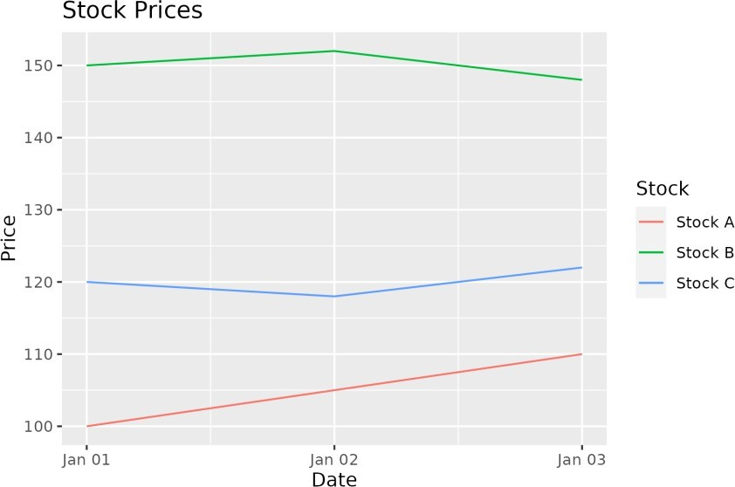

Figure 20.1: Q1 - Stock price line chart
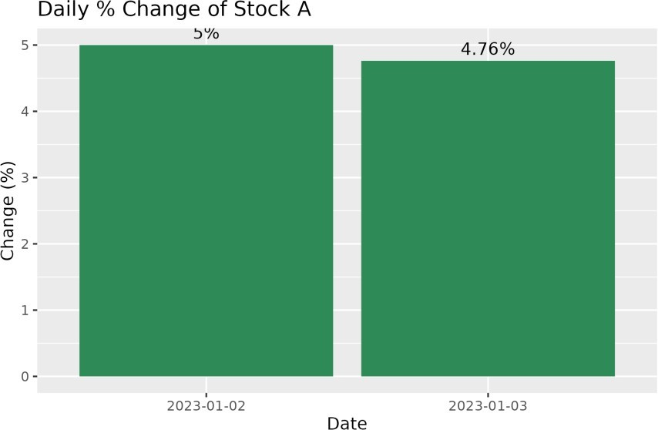

Figure 20.2: Q2 - Daily % change of Stock A
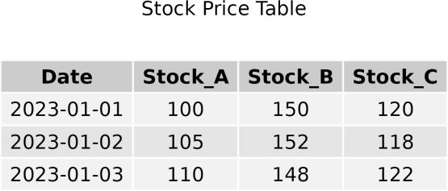

Figure 20.3: Q3 - Stock price table

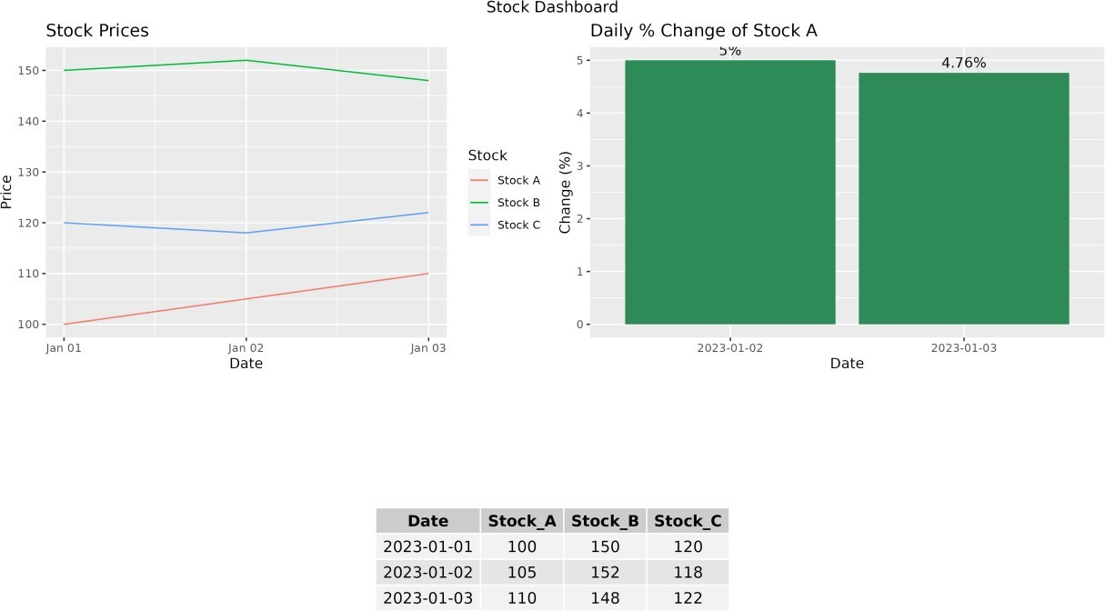

Figure 20.4: Q4 - Dashboard

Result
- Stock A rose from 100 to 110, with daily changes of +5.00% and +4.76%.
- Stock B and Stock C moved up and down.
- All four parts were completed successfully in R.

